**MUSIC MANAGEMENT SYSTEM**

DATABASE MANAGEMENT SYSTEMS PROJECT

**Name:** PRATYUSH ARORA

# **CONTENTS**

|  |  |  |  |  |
| --- | --- | --- | --- | --- |
| **Sl. No.** | | **TITLE** | **Page no** | |
| **1.** | | **Content’s Abstract** | 3 | |
| **2.** | | **Introduction** | 4 | |
| **3.** | | **Background, Motivation and Scope** | 5 | |
| **4.** | | **Methodology** | 6 | |
| **5.** | | **Requirements** | 7 | |
| **6.** | | **E-R Diagram** | 8 | |
| **7.** | | **Relational Database Design** | 9 | |
| **8.** | | **Database Normalization** | 10 | |
| **9.** | | **Data Directory** | 11 | |
| **10.** | | **Graphical User Interface** | 12-14 | |
| **11.** | | **Source Code** | 15-20 | |
| **12.** | | **Conclusion** | 21 | |
|  |  |  |  |  |
|  |  |  |  |  |

**CONTENT’S ABSTRACT**

This database is designed to manage all aspects of a music festival, including artist schedules, ticket sales, and event logistics. It allows festival organizers to easily track and manage information related to the performers, including their schedules and performance details. Additionally, the database is integrated with a ticket sales system, allowing for real-time tracking of ticket sales and revenue. This information can be used to make informed decisions about future festivals and track the success of the current event. Furthermore, it provides the functionality for tracking logistics such as stage setup, security, and vendor coordination. The database is a comprehensive tool that streamlines the planning and execution of the music festival and provides real-time insights into all areas of the event.

**2. INTRODUCTION**

Music management database systems are crucial for music industry professionals, such as record labels, music distributors, and publishers. These systems help organizations keep track of their extensive music catalogs and ensure that they are properly licensed and monetized. The database can store information on artists, albums, songs, and other music-related content, making it easier to search and retrieve the data as needed. Additionally, the system can provide data analytics and reporting capabilities, allowing users to track trends and make informed decisions about their music portfolio.

One of the key benefits of a music management database system is its ability to automate many of the manual processes involved in music catalog management. This includes tasks such as data entry, data reconciliation, and contract management. By automating these processes, the system can greatly increase the efficiency and accuracy of music data management. It also reduces the risk of human error and improves the overall reliability of the data.

Moreover, music management database systems can also provide enhanced security for sensitive information, such as licensing agreements and royalty payment details. This is especially important for organizations that handle large amounts of confidential information, as it ensures that their data remains secure and protected. By using a centralized database, music industry professionals can rest assured that their music data is stored in a secure and easily accessible location.

**3. BACKGROUND, MOTIVE AND SCOPE**

The background of music management database systems can be traced back to the need for efficient and effective management of music data. With the increasing amount of music being produced, it became necessary to develop systems that could manage this data in a centralized and organized manner. The early music management systems were primarily focused on storing and retrieving information about artists, albums, and songs.

The main motive behind the development of music management database systems is to provide a centralized repository for music data and to improve the efficiency and accuracy of music data management. By having a centralized database, organizations can avoid duplication of data and improve data accuracy, as well as provide a single source of information for stakeholders to access.

The scope of music management database systems has expanded significantly over the years, with modern systems incorporating features such as data analysis, reporting, and data sharing capabilities. Modern music management systems are also designed to be scalable, flexible, and secure, allowing organizations to manage their music data effectively, even as their music library grows.

In conclusion, the background, motive, and scope of music management database systems have evolved over time to meet the changing needs of organizations and to provide a centralized repository for music data. Today, music management database systems are an essential tool for organizations looking to manage their music data efficiently, effectively, and securely.

**4. METHODOLOGY**

]The methodology for developing a music management database system typically involves several key steps, including requirements gathering, design, implementation, testing, and deployment.

The first step in the development process is requirements gathering, where the system's requirements are defined and documented. This involves conducting stakeholder interviews and analyzing the existing processes to determine what the system needs to accomplish. During this step, it is also important to identify the stakeholders who will be using the system and their specific requirements.

Once the requirements have been gathered, the next step is to design the system. This involves creating a high-level design of the database, including the data model and relationships between tables. During the design phase, it is important to consider the normalization rules and the data integrity requirements, as well as the security and scalability needs of the system.

Once the design has been completed, the next step is to implement the system. This involves coding the system, as well as integrating any necessary software components. The implementation phase typically requires close collaboration between developers and the stakeholders to ensure that the system meets their requirements.

Once the system has been implemented, the next step is to test the system. This involves verifying that the system functions as expected, and that the data is being stored and retrieved accurately. During the testing phase, it is also important to identify any bugs or performance issues and to resolve them before the system is deployed.

Finally, once the system has been tested and any necessary changes have been made, it can be deployed. This involves making the system available to users and providing training and support as needed. The deployment phase is critical for ensuring that the system is adopted and used effectively, and for addressing any issues that may arise during the initial use of the system.

In conclusion, the methodology for developing a music management database system is a structured and well-defined process that involves several key steps. By following a defined methodology, organizations can ensure that their music management database systems are developed efficiently, effectively, and in accordance with their specific requirements.

**5. REQUIREMENTS**

Requirements are an essential component of any music management database system project. Requirements define the goals and objectives of the system and provide the foundation for the design, implementation, and testing of the system.

In the context of music management database systems, requirements typically include functional requirements, such as the ability to store and retrieve information about artists, albums, and songs, as well as non-functional requirements, such as security, performance, and scalability.

Functional requirements for music management database systems may include the ability to:

* Store and retrieve information about artists, albums, and songs
* Search for music data based on various criteria such as artist name, album name, or song title
* Generate reports and analysis on music data
* Manage the relationship between artists, albums, and songs

Non-functional requirements for music management database systems may include:

* Data security and privacy
* Performance and scalability to handle large amounts of data
* User-friendly interface and ease of use
* Support for mobile devices and web-based access
* Integration with other systems, such as payment systems or marketing systems

It is important to carefully document and prioritize requirements, as they will drive the design, implementation, and testing of the system. Requirements should be reviewed and validated with stakeholders to ensure that they accurately reflect the needs and goals of the project.

In conclusion, requirements play a critical role in the development of a music management database system. By carefully defining and documenting requirements, organizations can ensure that their music management database system is developed efficiently, effectively, and meets their specific needs.

**6. ER DIAGRAM**

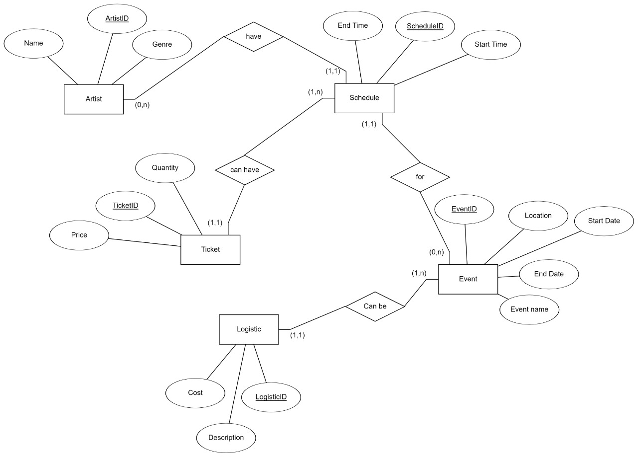

**7. RELATIONAL DATABASE DESIGN**

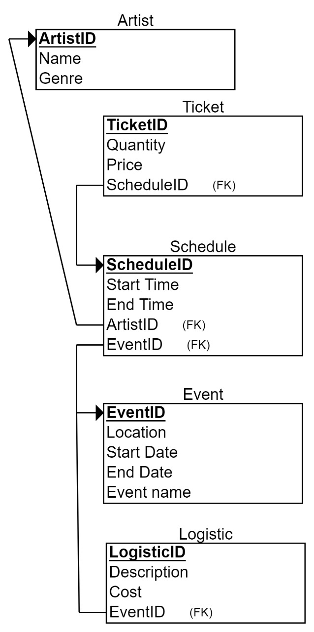

**8. DATABASE NORMALIZATION**

Database normalization is an important concept in music management database systems as it helps to ensure data integrity and reduce data redundancy. Normalization is the process of organizing data into separate tables to eliminate redundancy and reduce the risk of data anomalies. In the context of a music management database system, this would involve separating data such as artist information, album information, and song information into separate tables. This ensures that data is stored in a structured and organized manner, making it easier to manage and retrieve.

For example, the artist information table would contain information such as the artist's name, contact details, and biography. The album information table would contain information such as the album name, release date, and record label. By separating this data into separate tables, the system can ensure that data is stored in a consistent manner, making it easier to search and retrieve the information as needed. Additionally, normalizing the data helps to reduce the risk of data inconsistencies and ensures that the data remains accurate and up-to-date.

In conclusion, database normalization is a crucial aspect of music management database systems as it helps to ensure data integrity and reduce data redundancy. By organizing data into separate tables, the system can ensure that the data is stored in a structured and organized manner, making it easier to manage and retrieve. Additionally, normalizing the data helps to reduce the risk of data anomalies, ensuring that the data remains accurate and up-to-date.

**9. DATA DIRECTORY**

A data directory is a critical component of a music management database system as it provides a centralized location for storing and organizing data. The data directory is responsible for maintaining the data structures and relationships between tables, as well as enforcing data integrity and security constraints. It also provides an interface for users to access the data stored in the system.

In a music management database system, the data directory would store information such as artist information, album information, and song information. This information would be organized into separate tables and related to each other through defined relationships. For example, an artist table would contain information about the artist, such as their name, contact information, and biography, while the album table would contain information about the album, such as the album name, release date, and record label.

In conclusion, the data directory is a critical component of a music management database system, responsible for storing and organizing data, maintaining data structures and relationships, enforcing data integrity and security constraints, and providing an interface for users to access the data. By having a well-designed and maintained data directory, organizations can ensure that their music management database system is efficient, effective, and secure.

**10. GUI**

* FRONTEND-

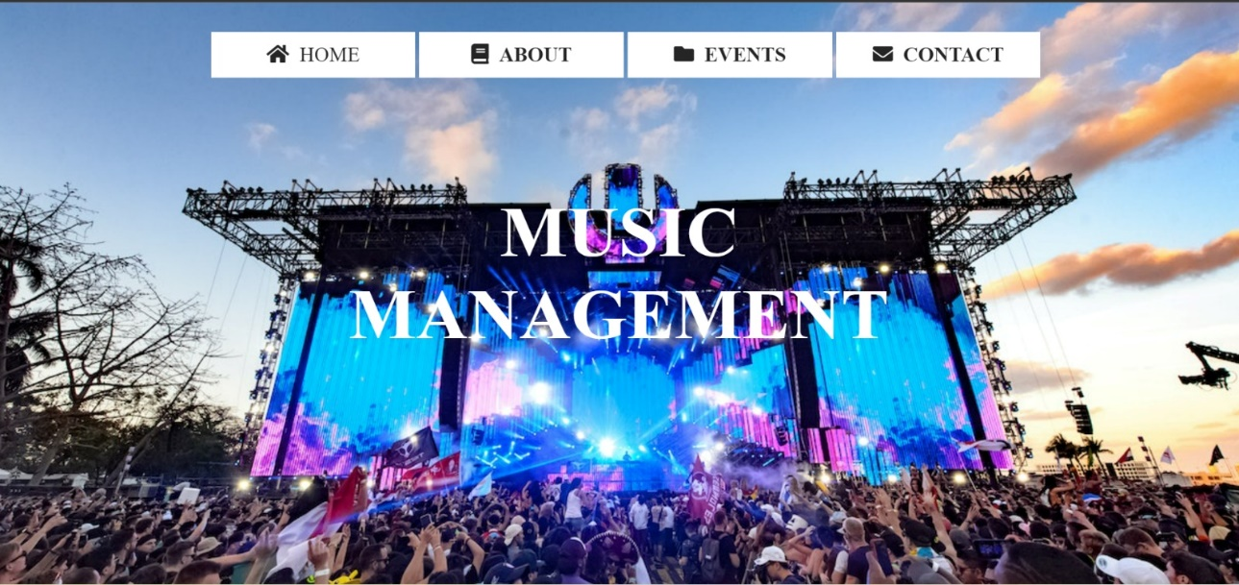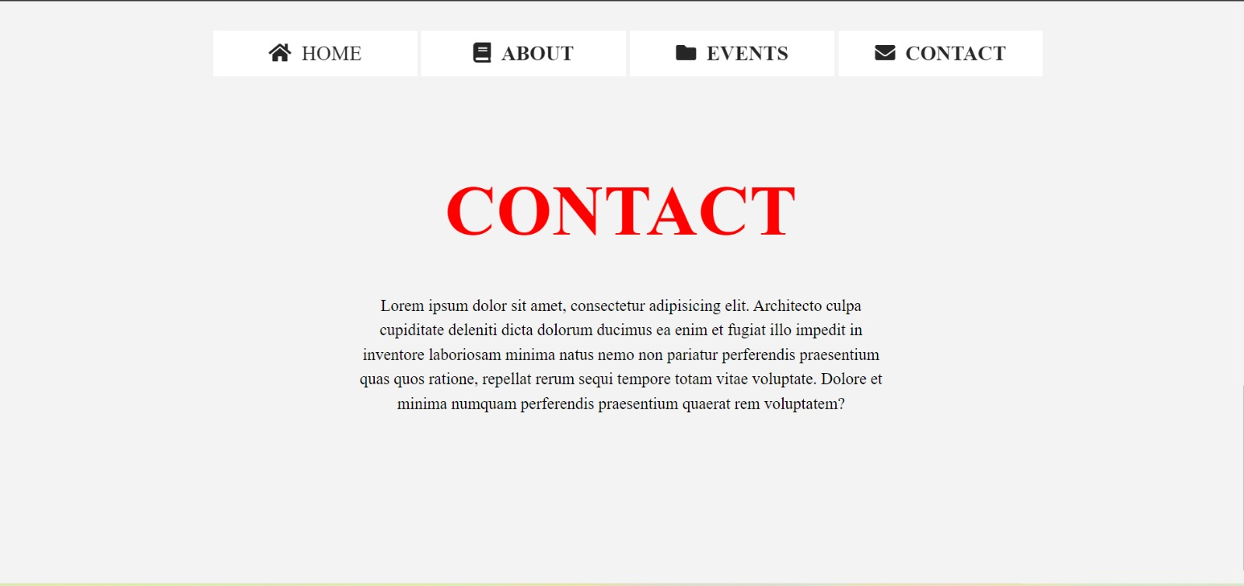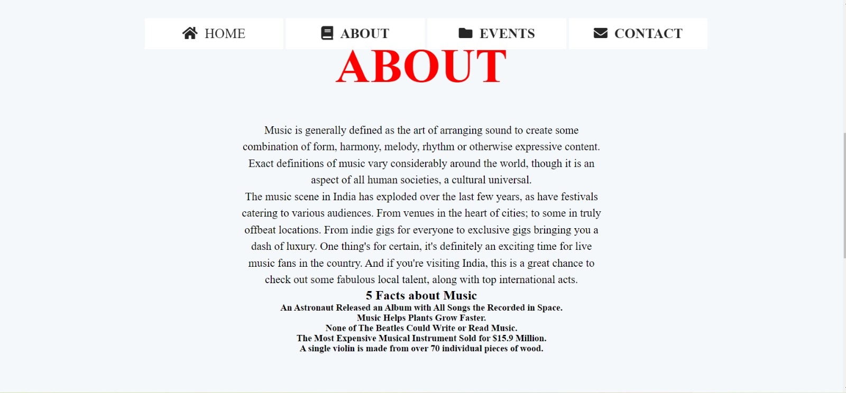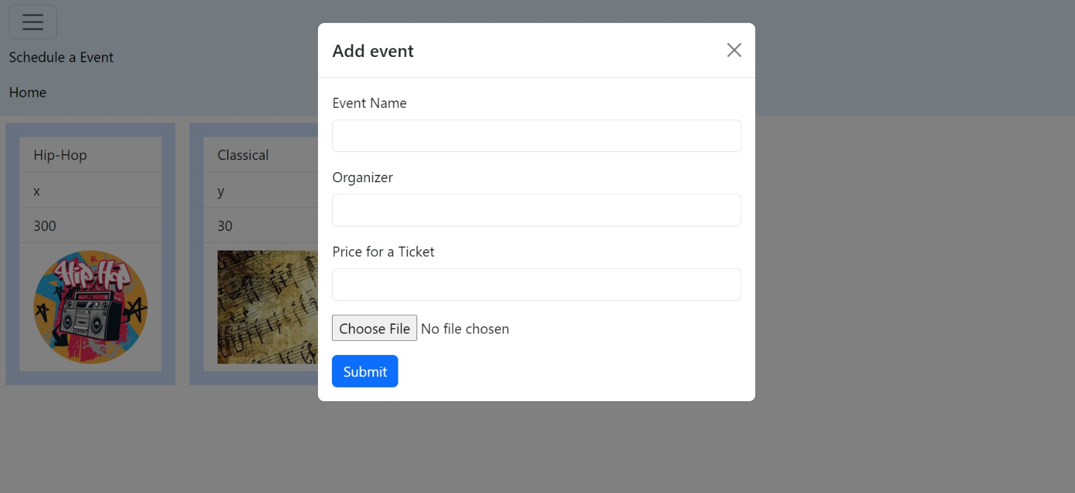

* BACKEND(DATABASE)

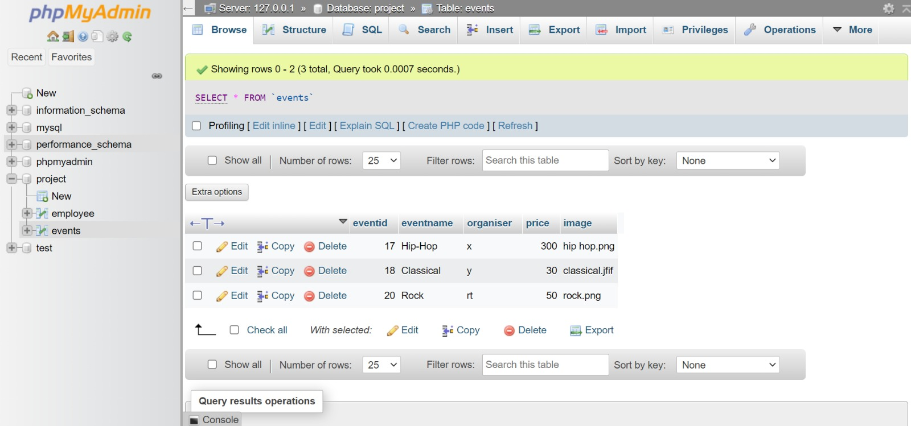

**11. SOURCE CODE**

* HTML

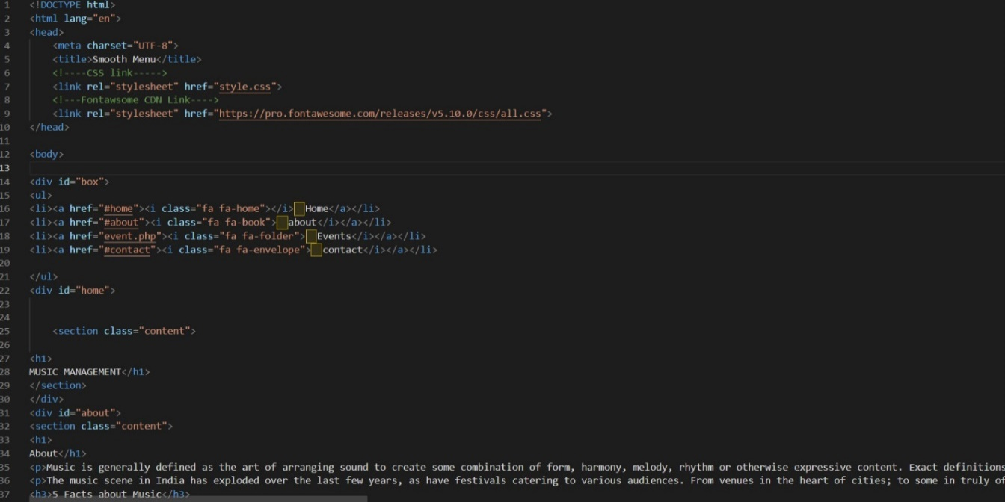

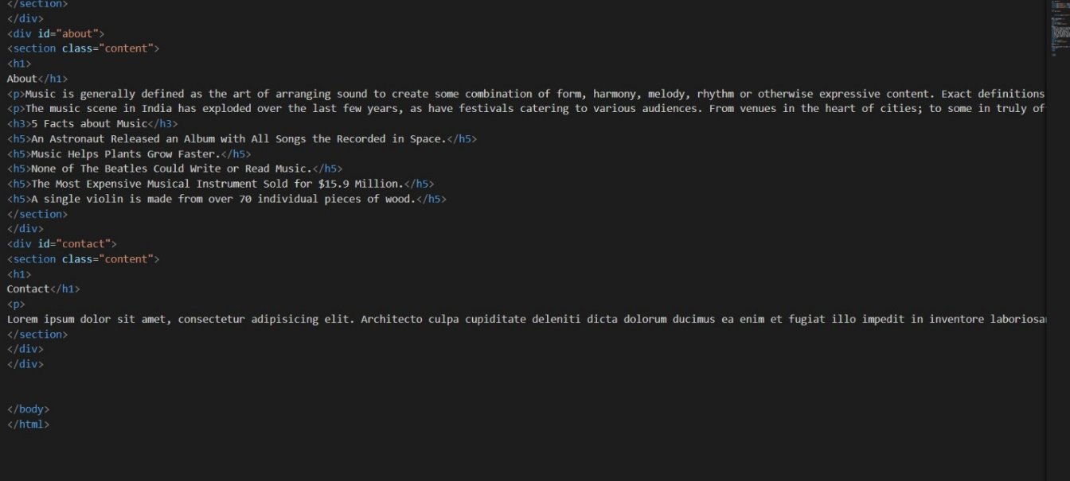

* PHP

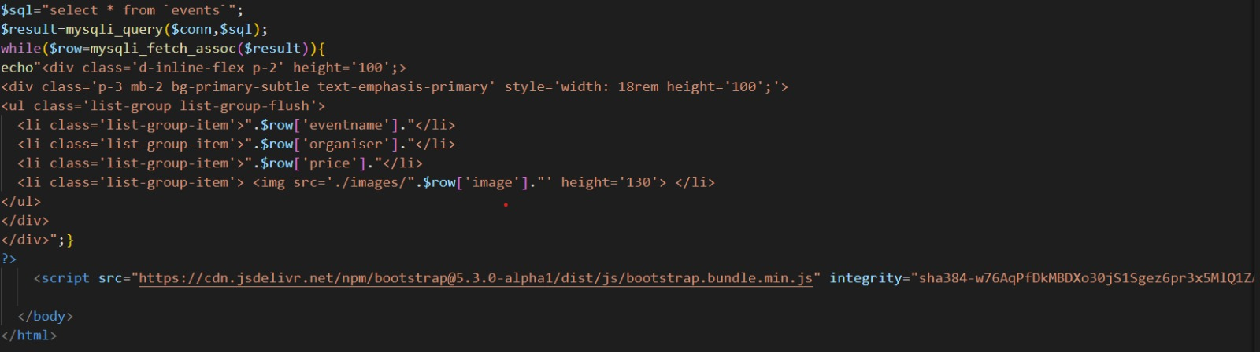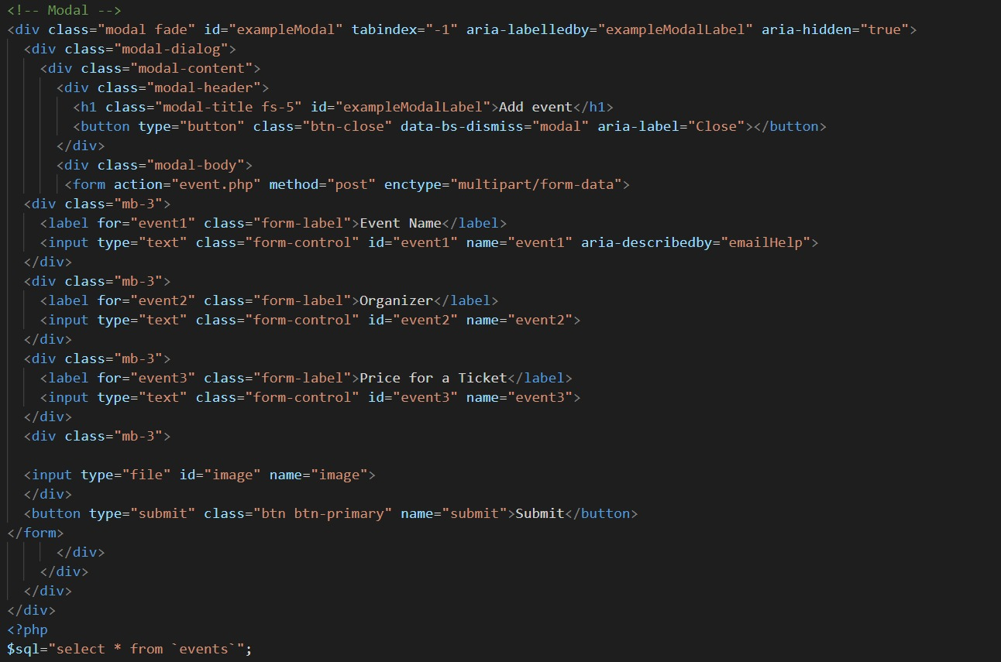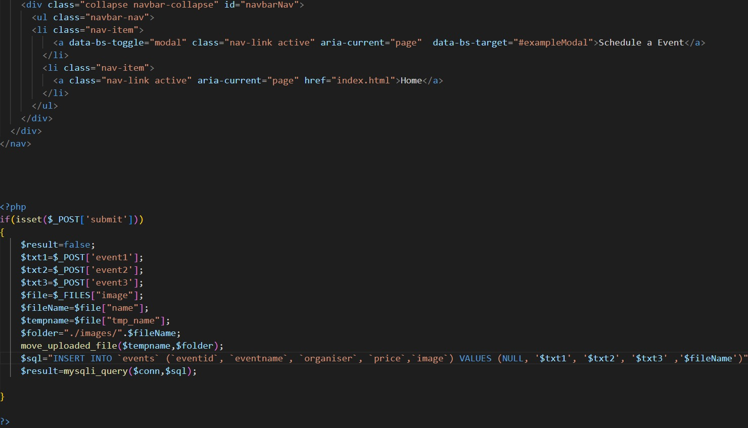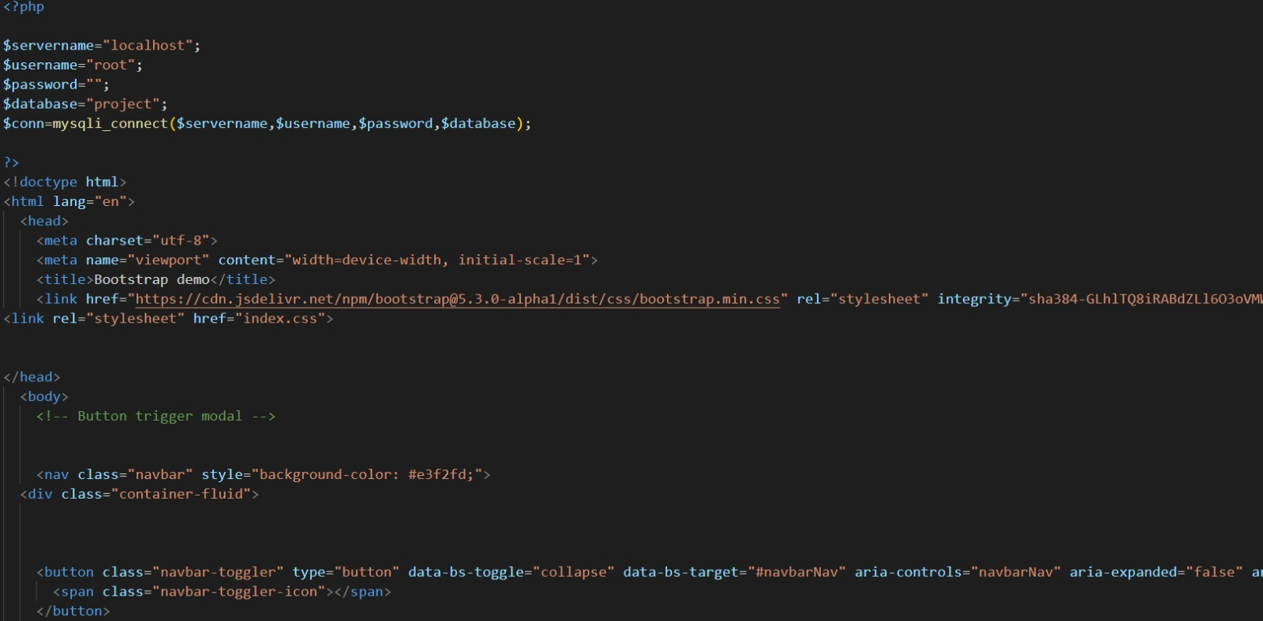

* CSS

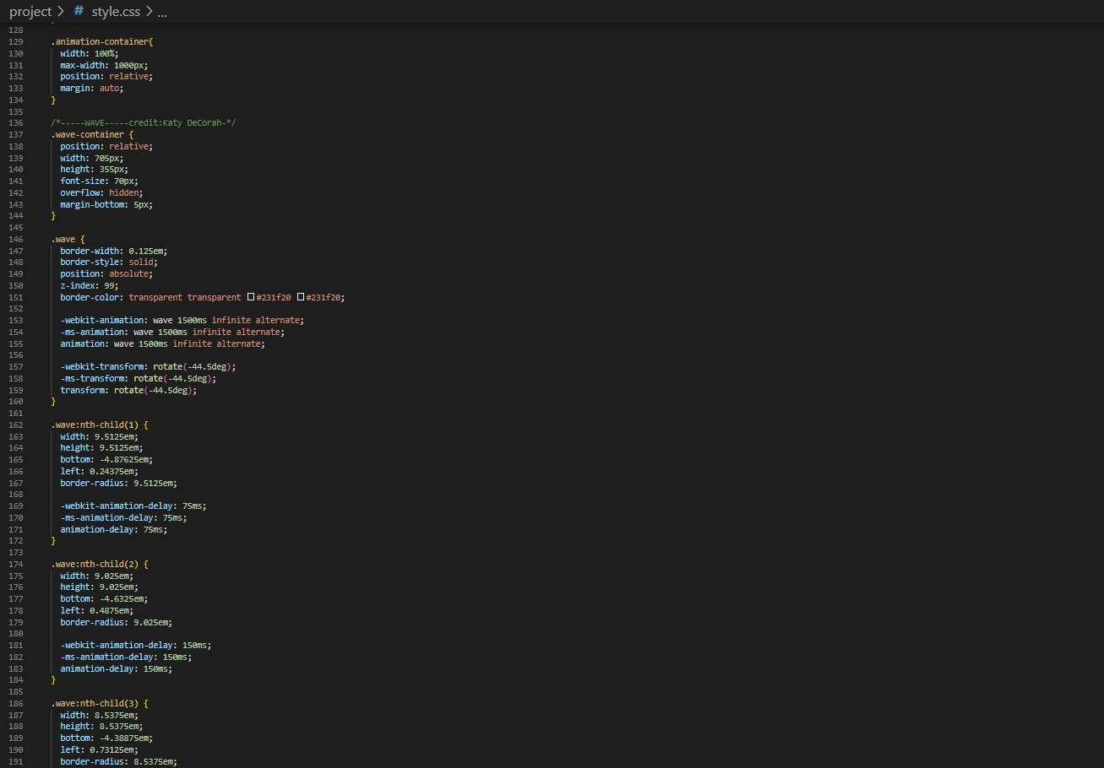

**12. CONCLUSION**

In conclusion, a music management database system is a critical tool for organizations looking to manage their music data efficiently and effectively. The system provides a centralized repository for music data, reducing duplication and improving data accuracy. By defining and documenting requirements and carefully selecting and implementing technical solutions, organizations can ensure that their music management database system meets their specific needs and goals.

In addition to its practical benefits, a well-designed music management database system can also provide valuable insights into the music industry, enabling organizations to make informed decisions and improve their overall performance. With the continued growth of the music industry, the importance of music management database systems is only expected to increase in the future.